Creating Command Line Utilities in Python
Command line utilities are programs that can be run from the terminal or command line interface, and they are an essential part of many development workflows. In Python, you can create your own command line utilities using the built-in argparse module.
Syntax
Here is the basic syntax for creating a command line utility using argparse in Python:
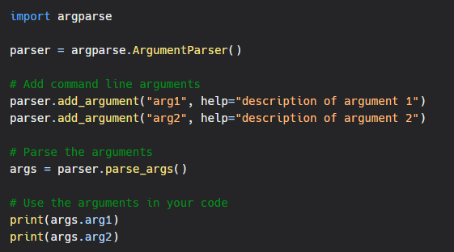Examples
Here are a few examples to help you get started with creating command line utilities in Python:
Adding optional arguments
The following example shows how to add an optional argument to your command line utility:
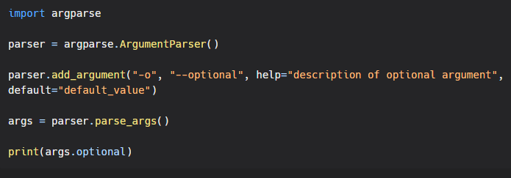

Adding positional arguments
The following example shows how to add a positional argument to your command line utility:
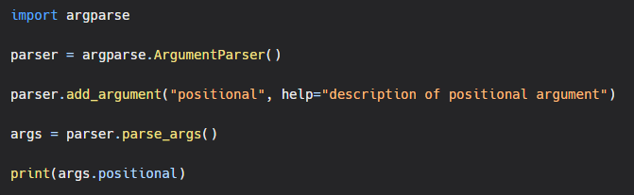
Adding arguments with type
The following example shows how to add an argument with a specified type:
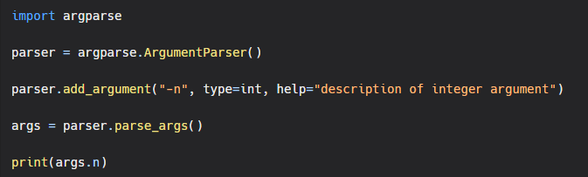Conclusion
Creating command line utilities in Python is a straightforward and flexible process thanks to the argparse module. With a few lines of code, you can create powerful and customizable command line tools that can make your development workflow easier and more efficient. Whether you're working on small scripts or large applications, the argparse module is a must-have tool for any Python developer.

